Allow cookies in browser
Google Chrome:
Using "On-device site data" (Recommended)
- Click the three-dot menu icon in the top-right corner of Chrome and select Settings.
- In the left-hand menu, click on Privacy and security.
- Select Site settings.
- Scroll down and click Additional content settings to expand it.
- Click on On-device site data.
- Under "Default behavior," choose "Allow sites to save data on your device".
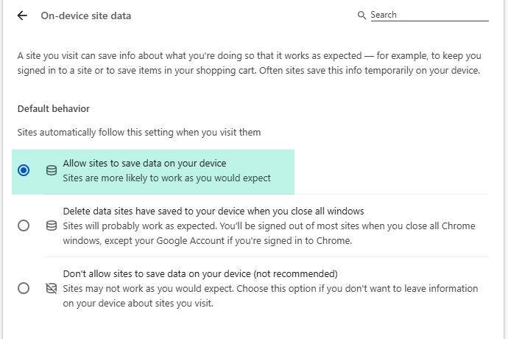

Microsoft Edge:
- Open Microsoft Edge and click the three dots (...) in the top-right corner.
- Select Settings from the dropdown menu.
- In the left-hand pane, click on Privacy, search, and services.
- Scroll down to the "Clear browsing data" section and click Choose what to clear every time you close the browser.
- Find Cookies and other site data in the list and toggle the switch to the "off" position.
- You can also enable other options, such as "Cached images and files," if you want to clear more data on exit.
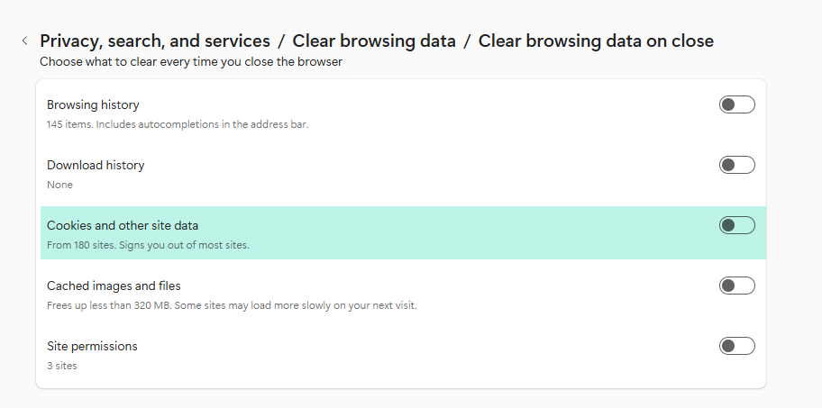

Mozilla Firefox:
- Open Firefox settings: Click the three horizontal lines (hamburger menu) in the top-right corner and select Settings.
- Navigate to Privacy & Security: Click on Privacy & Security in the left-hand menu.
- Find the option: Scroll down to the Cookies and Site Data section.
- Enable the setting: Check the box next to "Delete cookies and site data when Firefox is closed".
- Set exceptions (optional): If you want to keep cookies for certain websites, click the Manage Exceptions button to add the sites you want to keep cookies for.


